The following table shows Respite Services activity levels from 2019 – 2025
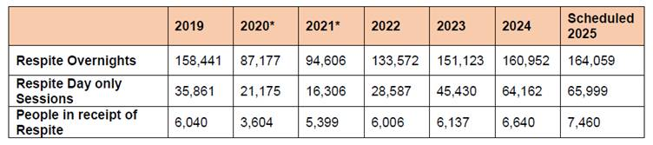

In this context, the table below shows the approximate number of respite overnights provided to children in the last five years.
