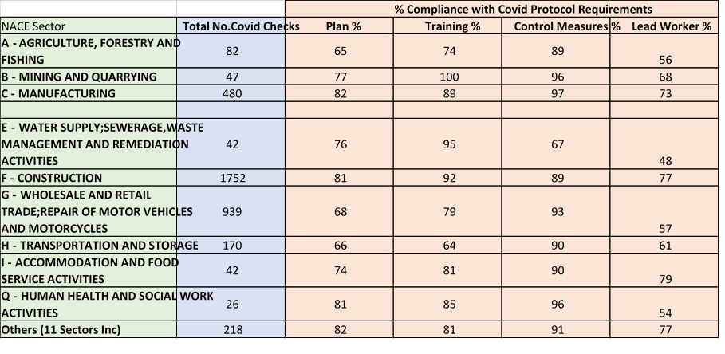
Health and Safety Authority - COVID-19 inspections by Sector – PQ 29961/20

