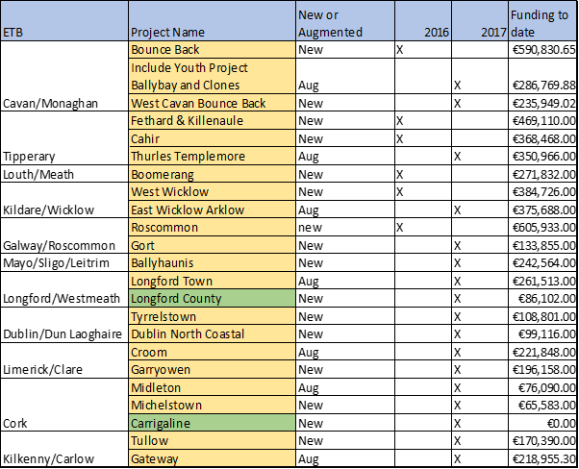

Operational in 2018
Operational in 2019

