CRAYFISH PLAGUE OUTBREAKS UPDATE

MAY 2019

Information note issued by National Parks and Wildlife Service, Department of Culture, Heritage and the Gaeltacht and Marine Institute.

The purpose of this note is to provide an update on the Crayfish Plague Outbreaks and associated information. These will be produced as, and when, significant new information is available. For more detailed information on the outbreak and advice on biosecurity, please refer to the pages on Crayfish Plague on the National Biodiversity Data Centre (NBDC) web site http://www.biodiversityireland.ie/projects/invasive-species/crayfish-plague/ . NPWS and the Marine Institute would ask that this information note is shared with all relevant staff, organisations and water users.
The following is a list of the rivers where outbreaks of Crayfish Plague have been confirmed by diagnostic tests. The map accompanying this information note shows the affected catchments in red and the locations of mortalities or positive tests using environmental-DNA indicated by the star symbol. PLEASE NOTE THE MAP ONLY SHOWS AFFECTED SITES WITH PROVEN CASES OF CRAYFISH PLAGUE. The disease is likely to have moved and any site within the coloured catchments should be treated as high risk. A more detailed version of the map is available from the web page given above and here https://maps.biodiversityireland.ie/Map/Terrestrial/Species/17487
The advice is that strict biosecurity is observed when working in all these catchments. The highest level of risk is moving equipment that has been used in an affected area to an unaffected catchment. The Crayfish Plague disease organism (a water-mould Aphanomyces astaci) is microscopic and invisible to the naked eye and is only viable in water. It is completely harmless to people, pets, livestock and all other freshwater organisms. The presumption should be made that any equipment which becomes wet and has been used in an affected catchment will be contaminated and there is a potential for spreading the disease to new sites.
Rivers with confirmed outbreaks (with year first detected)
1 River Bruskey/Erne, Co Cavan. (2015).
2. River Suir, Co Waterford and Tipperary. (2017)
3. River Deel, Co Limerick (2017)
4. River Barrow (2017). Crayfish Plague is now widespread in the main channel as far upstream as Monasterevin (detected 2018). A further area of infection is now confirmed (29/5/19) on the River Slate at Rathangan (not shown on map).
5. Lorrha River, Co Tipperary (2017)
6. River Al, Co Westmeath. (2018)
7. River Clare, Co Galway (2019). This is based on testing of water samples.
8. River Maigue, Co. Limerick (2019)
Northern Ireland had its first Crayfish Plague outbreak confirmed on the River Blackwater in Co Tyrone in 2018.
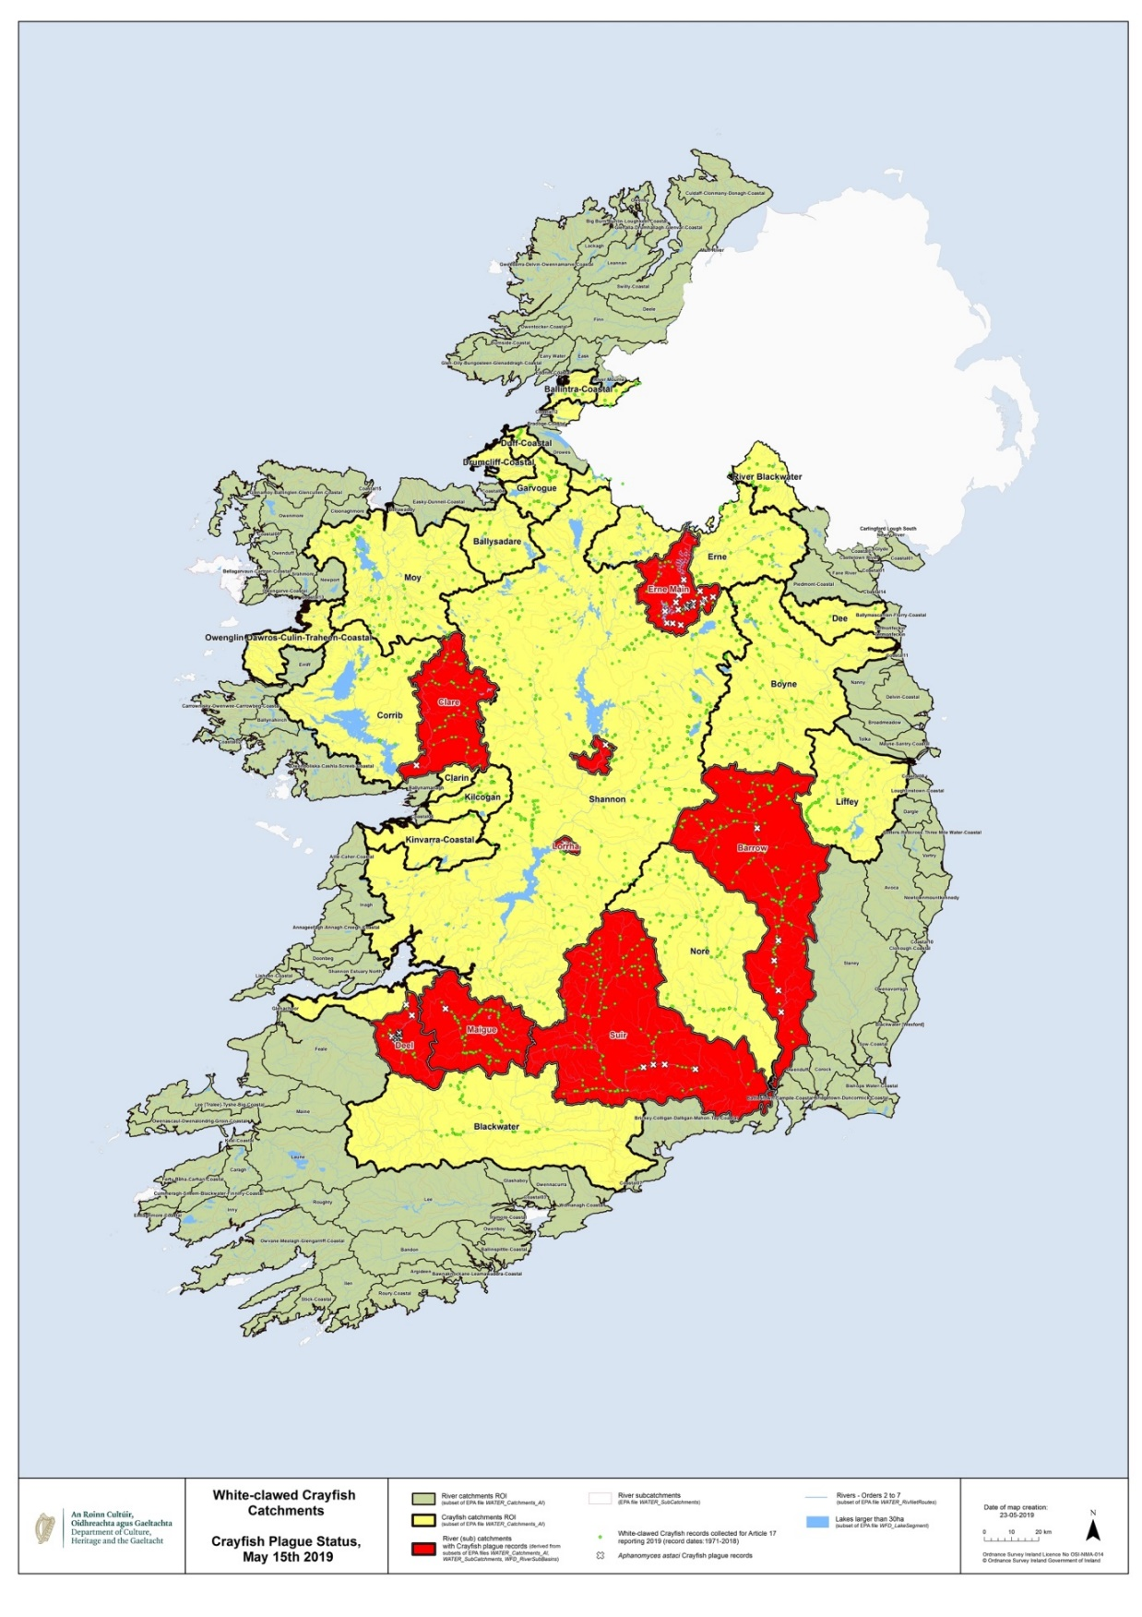
FIRST IRISH POPULATION OF A NON-INDIGENOUS CRAYFISH SPECIES
The NPWS can also confirm that a population of a non-indigenous crayfish species (NICS) has been found for the first time in the wild in Ireland.
There has always been a concern that a NICS may become established in Ireland and this has now been confirmed by the discovery of a population of an Australian Crayfish, the Yabby, Cherax destructor. NPWS are working at the site to assess the size of the population. The location is not being disclosed at this time.
PROTOCOL FOR SUSPECTED CRAYFISH PLAGUE OUTBREAKS
If Crayfish Plague is suspected please contact NPWS, the National Biodiversity Data Centre or the Marine Institute who will advise on actions to be taken.
BIOSECURITY
Ideally do not enter rivers which are potentially contaminated but if you do, Check-clean-dry should be used to decontaminate wet equipment BEFORE using it again in another river. For more information see http://www.biodiversityireland.ie/projects/invasive-species/crayfish-plague/

