**Details of the allocation of funding for adult literacy programmes and total number of beneficiaries are outlined in the tables below**



*\*2018 figures are estimates, based on projected numbers of beneficiaries and funding.*

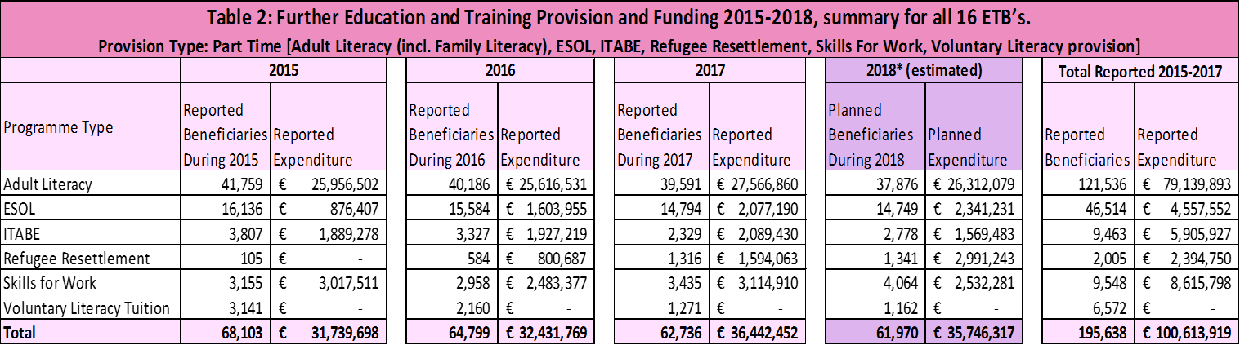

*\* 2018 figures are projections*

*\*\* Summary for the three year period (2015, 2016, and 2017) is provided, as per reported figures.*